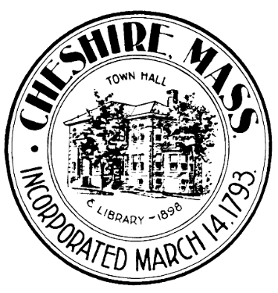
Cheshire - Police Chief Selection Survey

The Town of Cheshire wants to hear from the residents as we move closer to hiring a new Full Time Police Chief.. We've created a short survey where you can share your thoughts on the most important issues facing our community and the leadership qualities you want to see in the next Police Chief.
You’ll also have a chance to tell us anything else you'd like the town to consider during this process. Your feedback is anonymous and will play a key role in helping us choose the best leader for our community.

Please choose the three leadership qualities you believe are the most important for the next Police Chief to have.

- Honesty & Integrity
- Effective Communication and Listening Skills
- Transparency
- Compassion & Empathy
- Strategic Thinking
- Strong communication skills
- Other (please specify)

Please choose three professional experiences you would consider most important for the next Police Chief.

- Knowledge of Modern Policing & Best Practices
- Leadership Organizational Change & Reform
- Community Engagement & Events
- Public Communication & Media Relations
- Leading Initiatives That Improve Safety and Reduced Crime
- Experience in a Similar-Sized Community to Cheshire
- Other (please specify)

Please choose the top three things that the new Police Chief should focus on in their first year.

- Community Engagement & Participation
- Crime Prevention & Enforcement
- Emergency Preparedness & Public Health
- Modernizing – Practices, Technology & Equipment
- Traffic Safety and Enforcement
- Training and Operational Best Practices
- Officer Recruitment and Retention
- Other (please specify)

How would you like to see the next Police Chief engage in the Cheshire community? Check all that apply.
- Community Visibility and Event Participation
- Neighborhood Walks – Engage directly with residents and businesses
- Office Hours in the Community to meet with the public
- Citizen Surveys
- Sharing public data and department information
- Other (please specify)

Which one of these policing strategies would be the most important to you and the Community?
(Please select one)

- Community Policing (Engaging Community Resources, Events)
- Data-Driven Policing
- Hot Spot Policing (Focus on areas of High Crime)
- Problem – Orientated Policing
- Procedural Justice (Focus on clear procedures and fairness)
- Trauma Informed and Mental Health response

In our community, what do you believe is the most important issue the police department should address? Please write your answer in 40 words or less.

What is one area where you believe the Cheshire Police Department currently does a good quality job?

What is one area where you think the Cheshire Police Department needs to improve?

What is the first thing or issue you would advise the next Police Chief to focus on during
their first year on the job?

Please share any additional comments or feedback you may have related to the hiring of a new Cheshire Police Chief.

